4. Data on differences in student performance that may be directly attributed to the implementation of the curriculum element

Grades earned by “Successful Students”
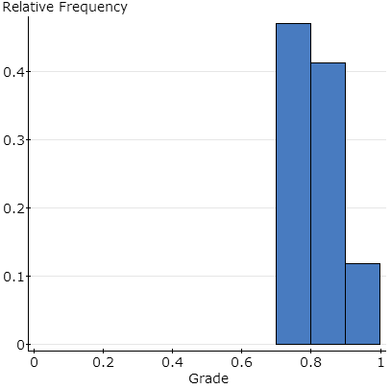
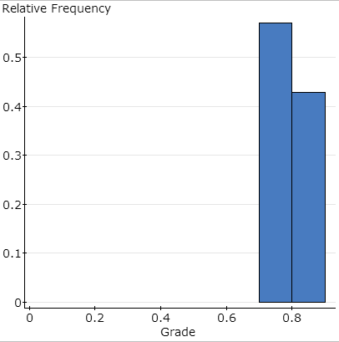
i.e. students who had passed more than 70% of their previous math classes at PGCC
Hands-On FA13 FA13
Traditional SP11 SP11

Note: In the figure above, blue bars indicate the performance of students in the traditional and hands-on (where the curriculum element was implemented) Math classes.

Grades earned by “Struggling Students” i.e. students who had passed less than 70% of their previous math classes at PGCC
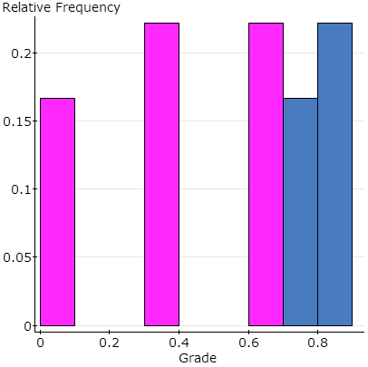
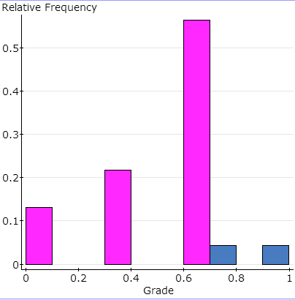
Hands-On FA13
Traditional SP11

Conclusion
“Successful Students” passed both Traditional and Hands-On classes.
“Struggling Students” pass rate improved significantly in the Hands-On class.

Note: In the figure above, pink and blue bars indicate the performance of students, who struggled in earlier Math classes, in the traditional and hands-on (where the curriculum element was implemented) Math classes.

