How to Compare Species Metabolic Pathways Using BioCyc
- Go to Biocyc.org
- Go to the “Tools” menu and select “Comparative Analysis”.
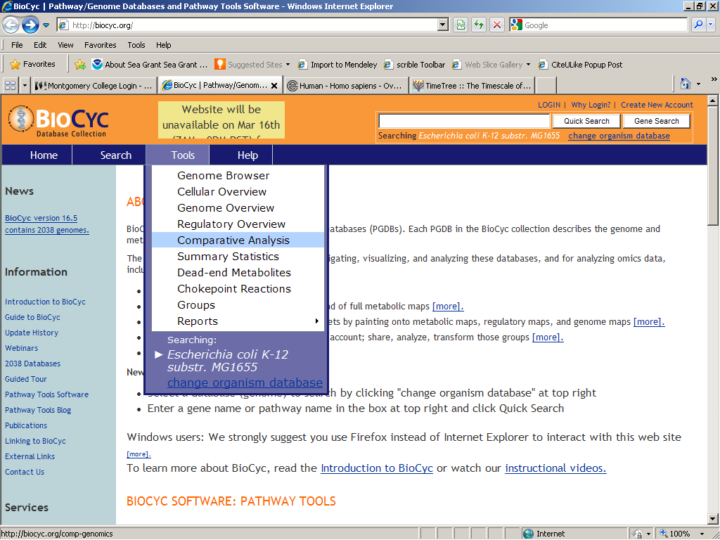
- On the “Comparative Analysis and Statistics” page, select “pathways”. 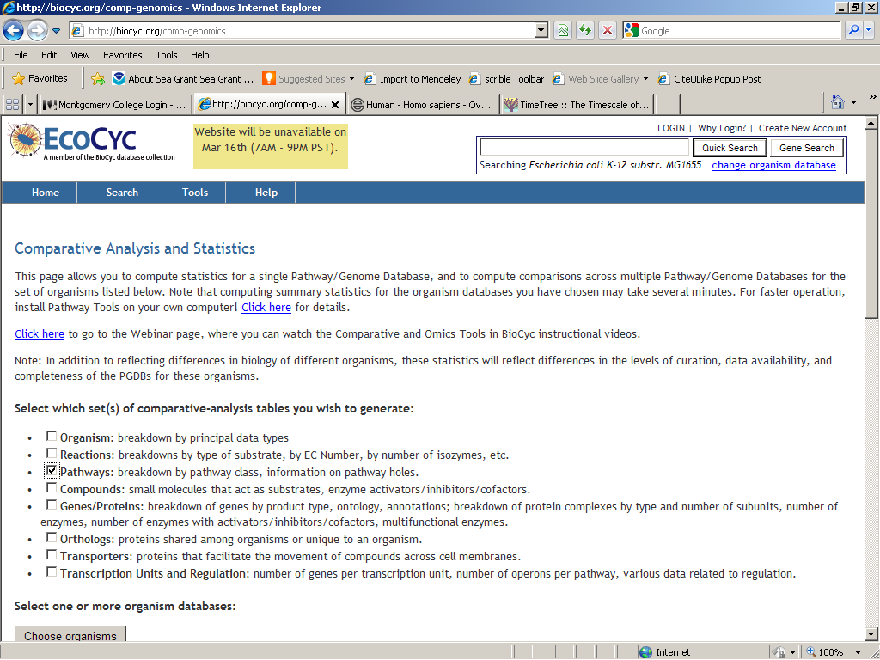

- Then click on the “Choose Organisms” button, which will bring up a pop-up window. If you get a warning about stopping a script from running, then just click “No”. You should see the selection window. 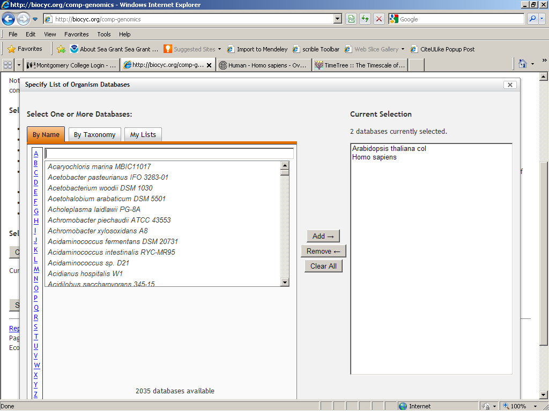
- Begin to type the name of the species you want to add and the name should appear. Click on it and add it to the “Current Selection” list. Click the “OK” button to finalize your selections.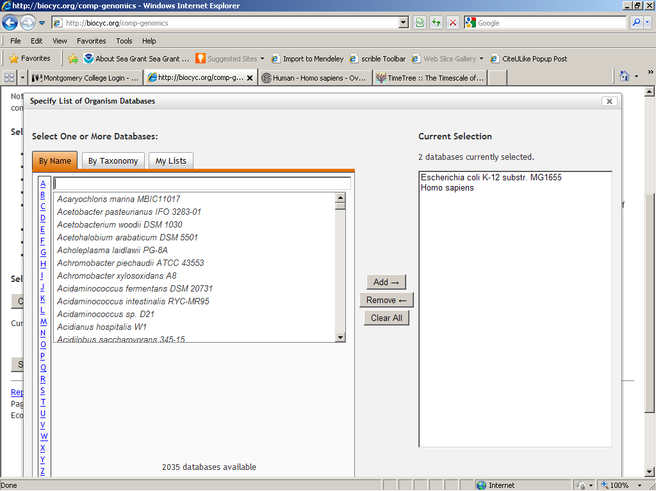

- Now click on the “Submit” button to run the analysis.
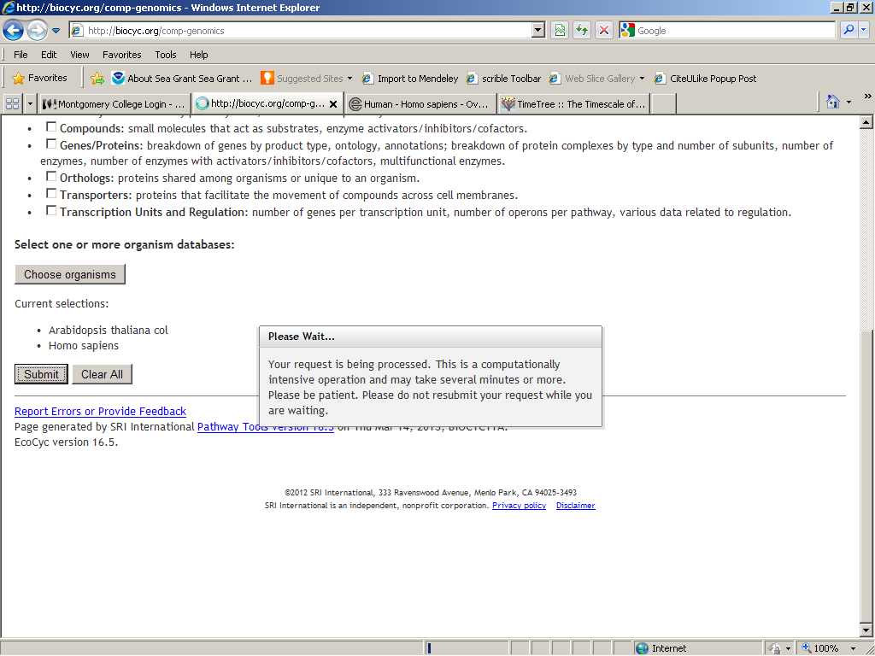

- Under “Pathways - Table 1: Breakdown of Pathways by Pathway Class”, look at the bottom of the table and click on the Pathway Class “Generation of Precursor Metabolites and Energy”.
Look for “glycolysis” or “glycolysis I”, etc. Notice whether there is an X on the table for both organisms. Explore the information.
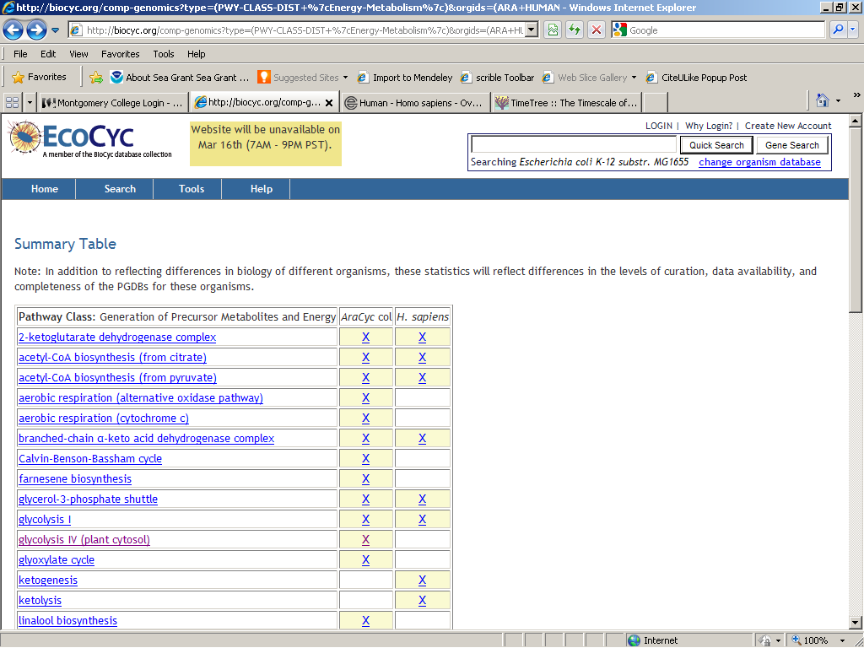

- Clicking on “glycolysis I” takes you to a “Cross-Species Comparison: glycolysis I”.
  - Here you can see an “evidence glyph” for each species’ pathway, a list of the enzymes ids and variations.
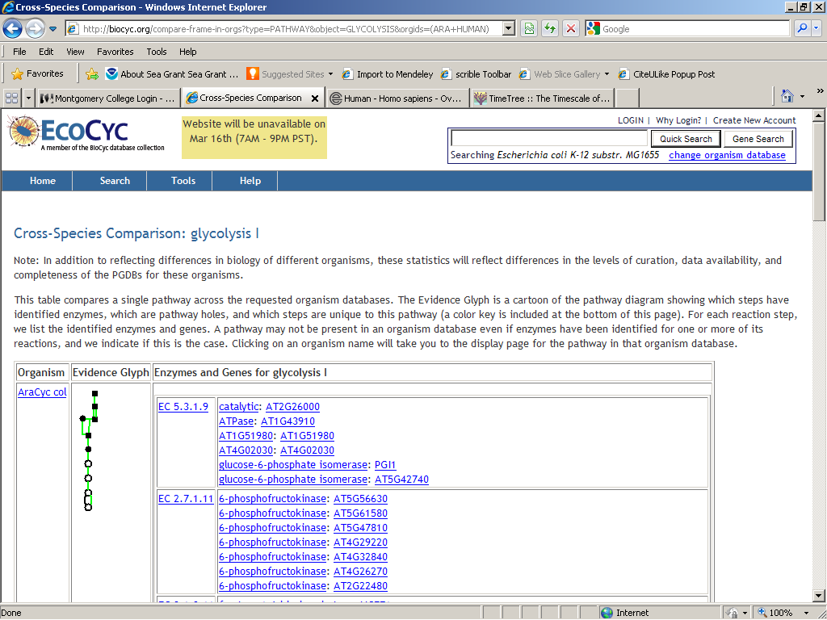

- Clicking on the “X” under the species in the table will take you to the metabolic pathway for that organism.
  - Here you can see the details of pathway and you can increase/decrease the amount of detail shown.
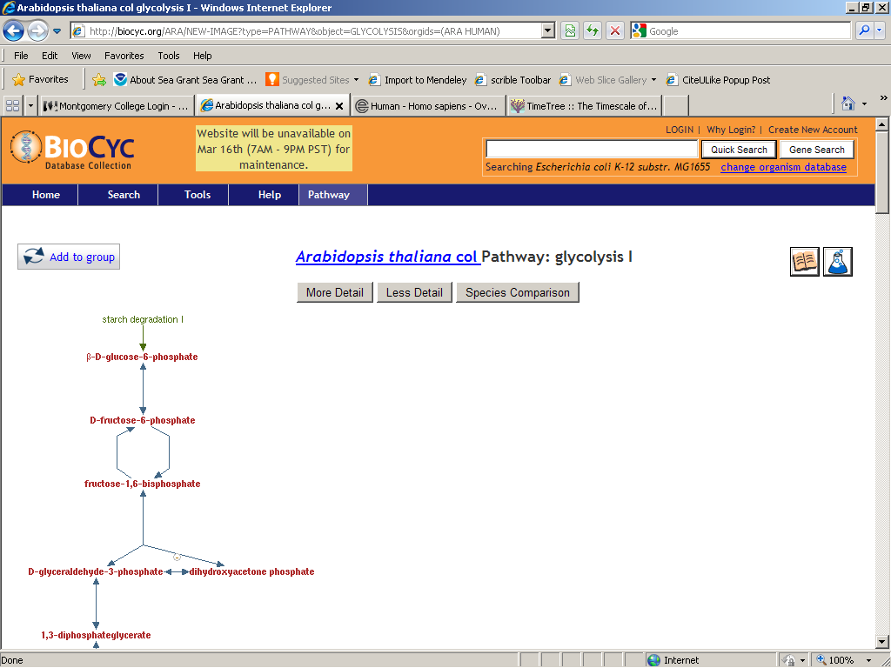
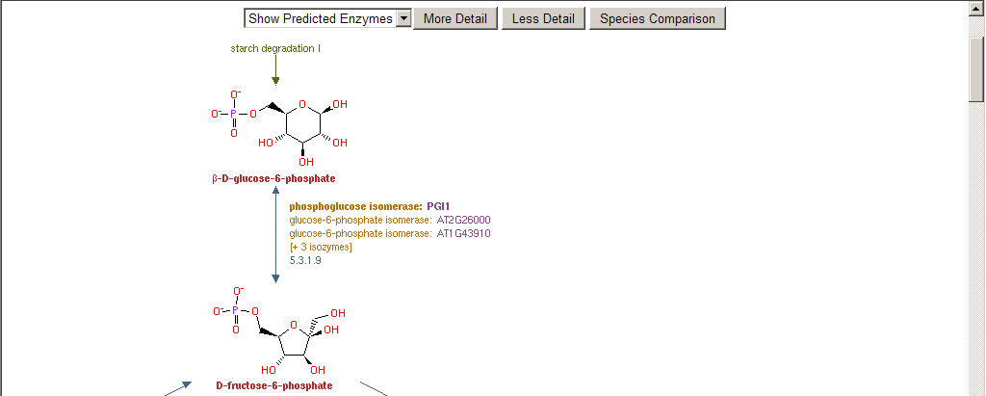
  - There is an illustration of the location of the glycolytic-enzyme-related genes on the chromosomes in that organism.
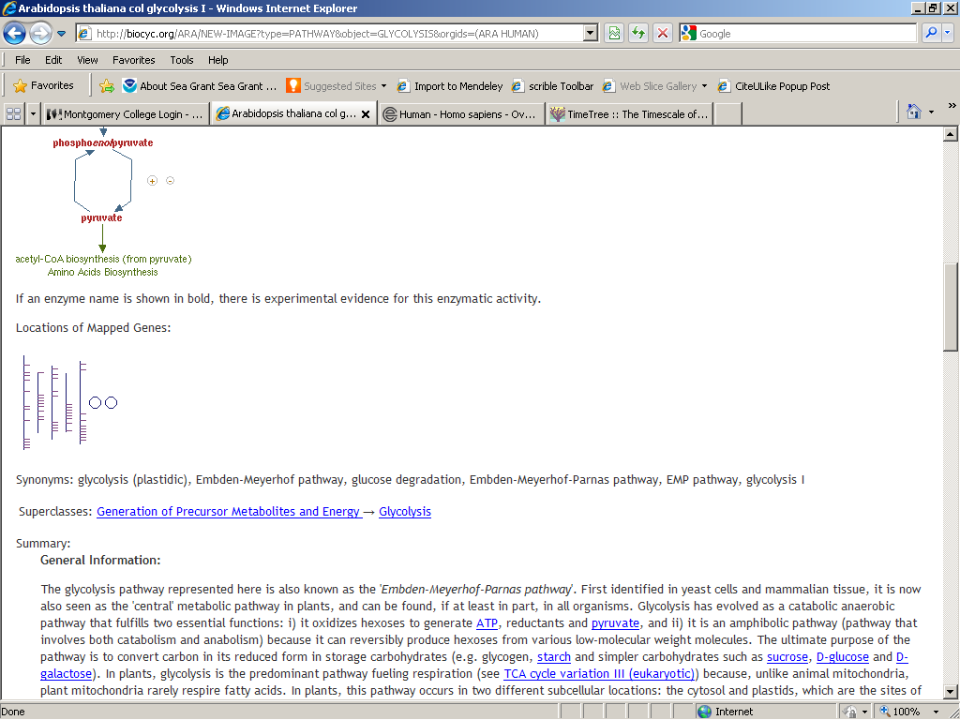
  - There is a summary describing the pathway.
  - There may be an “evidence glyph” for the pathway and/or other information.
  - There is a list of references from which the information on the page is derived.

