PH 262 Assignment
We have studied electric force, electric field, and electric potential. In order to gain some insights into the practical applications of these concepts, you will be looking at the electrostatic properties of some proteins. These properties play important role in the function of a protein in an organism. Using freely available software on the internet, you will visualize electrostatic potential around a protein.
Instructions
Go to the protein data bank (pdb) website http://www.rcsb.org/pdb/home/home.do to find a protein that interests you and do the following
- Write a short description of what it is and its function (1 paragraph)
- Use the website http://nbcr-222.ucsd.edu/pdb2pqr_1.9.0/ to enter the PDB ID of the protein
- Map out the equipotential surfaces.
- Identify the regions where the protein is more positive and more negative.
- Indicate/describe the regions of positive and negative regions on the picture

An example is shown below
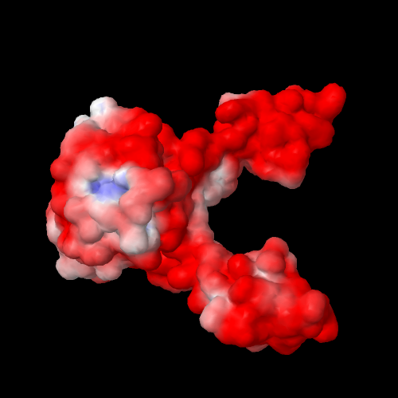

Fig. electric potential around a protein called integrase (PBID: 1ex4) that helps HIV virus stay dormant in humans for decades. Red is positive, white is neutral and blue is negative. http://www.rcsb.org/pdb/education_discussion/educational_resources/struct_bio_hiv_lores.pdf

For ideas on what protein to choose go to the website http://www.rcsb.org/pdb/101/structural_view_of_biology.do and you can check under educational resources.

