EET 130
The Wheatstone Bridge and Strain Gauges

Objectives
- Analyze series-parallel DC circuits
- Build and take measurements in series-parallel DC Circuits
- Use innovative and critical thinking to analyze a problem.

Recall from series-parallel circuits: the Wheatstone Bridge

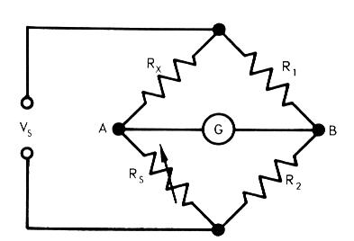

How can we redraw the circuit to facilitate analysis?

Using your redrawn circuit and the following values, compute the voltage between points A and B.

V_{S}=12V

R₁= 220Ω
R₂=100Ω
R_{x}= 3.3kΩ
R_{s}=2.2kΩ

V_{AB}= _________________________

Is this bridge balanced? ___________________

Notice the symbol for R_{S}. Recall that this symbol means a variable resistor, such as a potentiometer. By adjusting the value of R_{S}, we can “balance” the bridge.

How do we determine the value of R_{S} that will balance the bridge?

Application
One application for the Wheatstone Bridge is a strain gauge circuit, used for precision weighing or structural monitoring. In the typical strain gauge circuit, a foil strain gauge takes the place of one of the resistors. The resistance of the foil strain gauge changes as is it stretched or compressed. If we know the strain gauge characteristics, we can determine the amount of stretch or compression of the material or structure we’re measuring. We will discuss foil strain gauges and a new type of elastomer strain gauge in class.

