ENMA 466 Advanced Materials Fabrication Laboratory, Fall 2020

Dept of Materials Science and Engineering

Class: Wed 10:00am-11:30am, online/zoom
Labs: NanoCenter FabLab (KEB 2300) and possibly other related labs

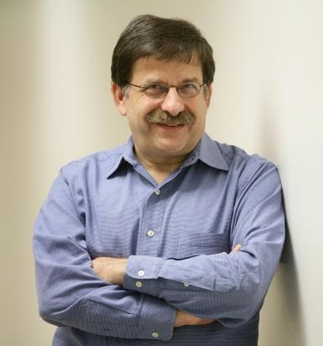 | Instructor  Prof. Gary W. Rubloff  Former Director, Maryland NanoCenter  Director, Nanostructures for Electrical Energy Storage NEES)  rubloff@umd.edu, http://www.rubloffgroup.umd.edu  (301) 405-3011  Office hours: Kim 1128, by appointment

Synopsis:
This course provides hands-on experience in the design and fabrication of micro/nano structures formed using a variety of thin film synthesis techniques. Fabrication will use the NanoCenter’s FabLab clean room, complemented by characterization using electron microscopy, electrical and optical methods. Small lab groups (~5) work together as project teams. They design microstructures intended to solve a problem, then fabricate them in the clean room, characterize the materials and devices, and carry out modeling and simulation analyses. Emphasis is on specifying process sequences and pattern layout to achieve desired 3-D structures. Project goals may be derived from ENMA 465 design projects or generated independently of them.

Course Objective:
- Provide a meaningful experience in thin film micro/nano processing through hands-on experimental and design projects centered on process combinations and sequences, mask/layout design for lithographic creation of 3-D structures, and design for functionality of the structures.

Special Arrangements for COVID-19 Restrictions
This semester’s classes will be significantly affected by COVID-19 restrictions imposed by UMD and the State for health and safety concerns. These affect the class and lab portions of the course differently, and together the progress of team projects is the key goal of the course.
Classes are scheduled Wednesdays 10:00am-11:30am and will be held primarily online through Zoom. Attendance is important since the weekly class provides an opportunity to gauge progress on the team-based projects.
Labs are scheduled on an ad hoc basis for students to carry out experiments, primarily in the FabLab cleanroom of the NanoCenter. A subset of a team (1-3 people) schedules time for a FabLab process as part of their fabrication and measurement plan for the device goal. The FabLab space is large, so that social distancing requirements are fairly easily met. FabLab staff will carry out a larger portion of the work than under normal conditions, with students watching; this minimizes the need for more extensive training where social distancing is more difficult.
Team projects each involve a small group of students (3-6) who can arrange the distribution of responsibilities, meeting times and places (mostly online this semester), acquisition of needed materials, scheduling of FabLab tool time with the staff, etc. While fabrication and testing are primarily carried out in FabLab, other esseential activities for the team can be done at home, or online, including device design, modeling and simulation, process flow and choice of FabLab tools, choice of process parameters, literature review, report writing, project management, etc. Thus only part of the project team (~50% or less) is needed for the fabrication and testing in FabLab, although it is beneficial for the others to visit some operations in FabLab for completeness of their exposure to microfabrication. To the extent that COVID-19 restrictions are in place or become more severe, we will shift emphasis to non-lab activities, particularly modeling and simulatio.

Prerequisite:
ENMA 465 and permission of the department.

Grading:

Component | How judged | %
Project outcome | Team | 30
Project report/presentation | Team | 20
Contribution to project, class | Individual | 25
Project notebooks | Individual | 15
Other individual assignments | Individual | 10

MSEMS criteria:
- Students understand the relation between patterning and process
- Students demonstrate some ability to use lab equipment to process and characterize materials and structures
- Students can design mask patterns to make specific structures

Diversity:
The University of Maryland has embraced diversity as a central driver in all its activities and has supported and promoted pioneering scholarship of diversity in academic programs. Our diversity is fundamental to our excellence and has enriched our intellectual community. The University’s capacity to educate students for work and life in the 21st century and to be a leader in research and scholarship is greatly enhanced by a community that reflects the nation and world. Diversity is a core value and strength of the University of Maryland

