ENMA 465 Microprocessing of Materials, Spring 2018
Dept of Materials Science and Engineering

Mon & Wed 3:30-4:45pm

Room 2324 technology classroom (google map)

Atlantic Bldg (ATL, Bldg 224)

Course Website on CANVAS: https://myelms.umd.edu/courses/1179073

Instructor:
Prof. Gary Rubloff, rubloff@umd.edu,
301-405-3011
Office: Kim 1128, hours by appointment
Director, Maryland NanoCenter
Director, Nanostructures for Electrical Energy Storage NEES), a DOE EFRC

Teaching Assistant:
Megan Kimicata, mak5467@terpmail.umd.edu
Office: Kim Bldg 2241
Office hours – send email

Synopsis
The goal of the course is to familiarize the students with basic as well as state of the art knowledge of technologically relevant topics in microprocessing and nanoprocessing as used in the semiconductor and related industries to fabricate ultrathin material layers, structures, and devices. Key processes are discussed in the context of their underlying physics and chemistry and how they influence the resulting materials properties. Concepts of process and device integration will be highlighted because fundamental interactions between process steps play a particularly important role in determining the performance of micron and nanometer sized structures. These sources of understanding provide a strong background for applications ranging from evolutionary semiconductor device technology to recent developments and opportunities in nanotechnology for energy, biotechnology, electronics, sensing, and other materials applications.
The basic framework of the course content comprises the set of deposition, patterning, etching, and planarization processes required to make small 3-dimensional devices. The students will develop skills in identifying, understanding, and exploiting basic mechanisms in microprocessing and gain a broad perspective on how this knowledge can be used industrial applications of microprocessing. The course will include laboratory sessions in the Maryland NanoCenter’s FabLab clean room and an exercise in process and device design.

Course Objectives:
- Provide an overview of thin film microprocessing, from chemical and physical fundamentals at the microscopic level to applications in microelectronics, nanotechnology, and other areas.
- Identify and understand key concepts which transcend the various embodiments of microprocessing, so that students will be able to recognize the role of these concepts in diverse applications.

Lectures will focus on topics covered in lecture notes (distributed after class) and the textbook, supplemented by other resources.

Homework and exams will be based on materials covered in lectures and reading assignments.

Lab exercise – microfabrication of cantilever devices. The course will include a ~4 week laboratory exercise where students will fabricate and then characterize microcantilever device structures. The class will be divided into groups of 5-6 students each, with each group assigned to a morning (9-12) or afternoon (12:30-3:30) session in FabLab. The lab exercises will be taught by FabLab staff. Students should pay attention and take notes during the lab so that they are prepared for questions on the lab exercise, either in in-class quiz or final exam.

Design exercise – process and mask design. To complement the lab exercise, students will work in their lab teams to specify a sequence of process steps and a set of lithography mask designs that could be use to fabricate a different device, a bottom-gate thin film transistor. The mask design will be done using AutoCAD, whose use will be taught earlier in the course.

Grading | Weight
Final exam | 25%
Quizzes | 20%
Homework | 20%
Design project | 25%
Class participation | 10%

Resources:

Slides used in lectures will be posted on Canvas after each lecture period, representing the primary resource for the course.

The following textbook is recommended as an additional but optional reference for the course. If you think you have enduring interest in areas that employ microfabrication/microprocessing techniques, this would serve well as a reference beyond the ENMA course.

Required Textbook  Introduction to Microfabrication, 2nd edition, 2010  Sami Franssila  Wiley  You can purchase it in 3 forms:  - Hardcover (~$72 new)  - Kindle e-book (~$60-70)  - Apple i-book (~$72)  I recommend the e-book version, allowing annotation and other functions as well as portability. I have purchased the ebook and downloaded it to Mac laptop and iPad successfully from Amazon, demonstrating that you can have copies in multiple places. I expect the Apple i-Book version will behave similarly. | 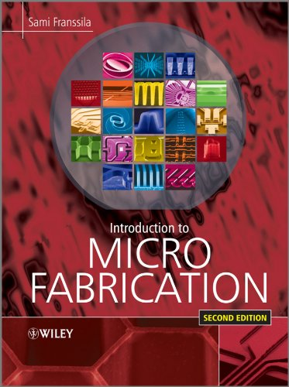  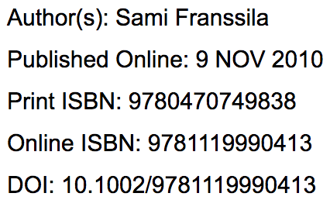

Additional reference books:

Fabrication Engineering at the Micro- and Nanoscale, Third Edition
Stephen A. Campbell
Oxford Press, paperback ($85.45 new at bookstore)
ISBN 978-0-1-9532017-6

Fundamentals of Semiconductor Fabrication (about $80)
Gary S. May and Simon M. Sze
Wiley 2004, ISBN 0-471-23279-3

Silicon VLSI Technology (Fundamentals, Practice and Modeling) by James D. Plummer, Michael D. Deal, and Peter B. Griffin

Introduction to Microelectronic Fabrication, 2nd edition
Richard C. Jaegar (1988)
Addison-Wesley Modular Series on Solid State Devices, ISBN 9780201444940

